NEWS
RELEASE
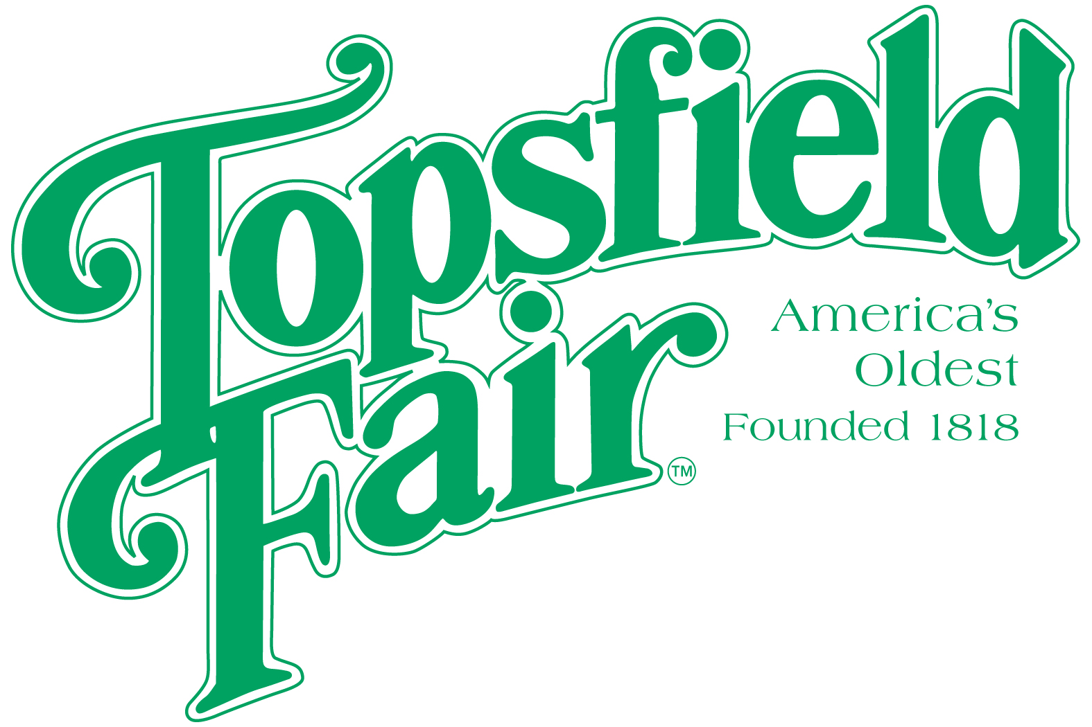

Media Contact: David Thomson

Thomson Communications
978-808-7700

TAYLOR’S STORY: AN UNOFFICIAL TRIBUTE TO TAYLOR SWIFT COMES TO THE TOPSFIELD FAIR ON OCTOBER 8TH

TOPSFIELD, Mass. (August 22, 2025) – The 207th Topsfield Fair, running October 3-13, 2025, invites you to step into the enchanting world of “Taylor’s Story,” an unofficial tribute to Taylor Swift. This concert, taking place on the Grandstand stage on Wednesday, October 8, 2025, promises to deliver an authentic Taylor Swift experience, featuring Shannon, a seasoned performer with a background in country music, who brings Swift's iconic hits to life with remarkable vocal precision and stage presence. Accompanied by a talented four-piece band, Shannon's performance is set to transport audiences into the heart of Taylor Swift’s world, capturing the energy, charisma, and flair that has made Taylor a global phenomenon. Attendees can look forward to a family-friendly celebration, offering fans of all ages the opportunity to immerse themselves in the magic of Taylor Swift's music.

Whether you're a longtime Swiftie or new to her music, “Taylor’s Story” is an event not to be missed. This event is fan-sponsored and not endorsed by or affiliated with TAS Rights Management, Taylor Swift, or their affiliated entities.

Ticket prices for the 2025 Topsfield Fair are $20.00 each every day. Discount admission tickets are available at www.topsfieldfair.org through October 2, 2025. General Admission discount tickets can be purchased for only $15.00 plus a $3.00 convenience fee, which are good any day during the Fair’s 11-day run. A three-day pass, good any three days, is available for $42.00 plus a $3.00 convenience fee. Children under eight are free with an adult admission ticket. Discounted food vouchers and ride tickets are also available when purchased in advance at www.topsfieldfair.org.
###

