NEWS
RELEASE
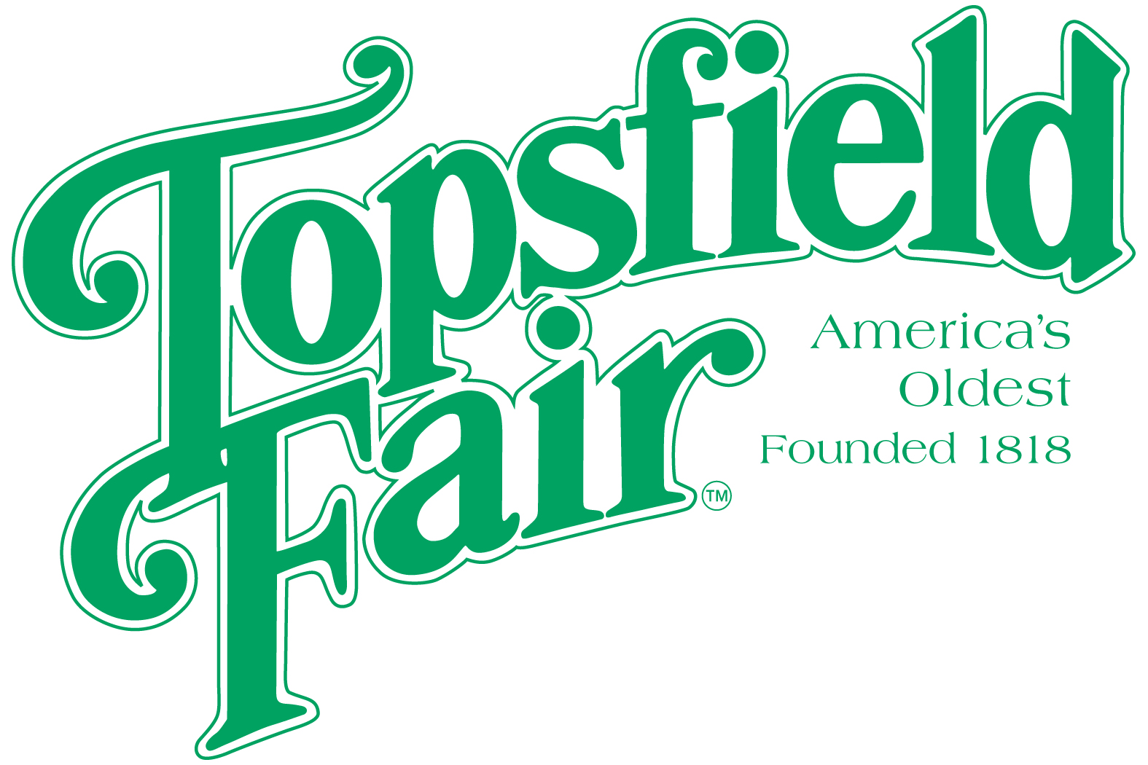

Media Contact: David Thomson

Thomson Communications
978-808-7700

SAMMY KERSHAW TO PERFORM AT THE TOPSFIELD FAIR

TOPSFIELD, Mass. (August 21, 2025) – The 207th Topsfield Fair, running October 3-13, 2025, announces that country music artist, Sammy Kershaw will perform on Thursday, October 9, 2025.

Grammy nominated performer, Sammy Kershaw, helped shape and make the ‘90s a shining decade for country music. His multi-platinum albums were propelled into the record books by hits such as “She Don’t Know She’s Beautiful,” “Queen of My Doublewide Trailer,” “I Can’t Reach Her Anymore,” “National Working Woman’s Holiday,” “Love Of My Life,” “Cadillac Style,” “Don’t Go Near The Water,” “Haunted Heart,” “Vidalia” and many others.
Sammy Kershaw’s concert is scheduled to begin at 7:00 p.m. on the Grandstand stage and is free with paid fair admission. “We always get requests from attendees for great country artists to perform at the Fair, and I certainly think they will be very happy to see Sammy Kershaw perform live,” said James O’Brien, General Manager, Topsfield Fair.

Ticket prices for the 2025 Topsfield Fair are $20.00 each every day. Discount admission tickets are available at www.topsfieldfair.org through October 2, 2025. General Admission discount tickets can be purchased for only $15.00 plus a $3.00 convenience fee, which are good any day during the Fair’s 11-day run. A three-day pass, good any three days, is available for $42.00 plus a $3.00 convenience fee. Children under eight are free with an adult admission ticket. Discounted food vouchers and ride tickets are also available when purchased in advance at www.topsfieldfair.org.
###

