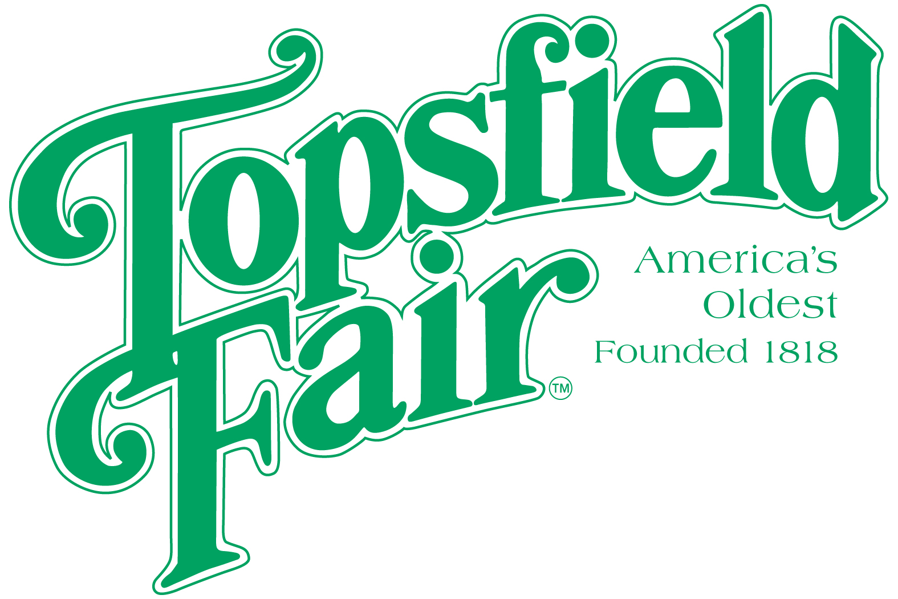
NEWS
RELEASE

Media Contact: David Thomson

Thomson Communications 978-808-7700

MRS. ESSEX COUNTY PAGEANT 2025 SEEKS CONTESTANTS

TOPSFIELD, Mass. (September 26, 2025) – The Mrs. Essex County Pageant will crown the 54th Mrs. Essex County at this year’s Topsfield Fair. Through the years, hundreds of women have entered the contest for the honor of representing the Essex Agricultural Society at local events and serving as an ambassador of the Topsfield Fair.
Not a beauty competition, the Mrs. Essex County Pageant invites contestants who must be married, currently living in Essex County with their spouse, and at least 18 years of age to enter. Each contestant will submit a prepared food item. This year's category is favorite tailgate appetizer.
Contestants will be judged according to the following criteria: general appearance, personality, poise, and food score.
This year’s pageant will be held in Coolidge Hall on the Topsfield Fairgrounds on Sunday, October 12th at 1:00pm. Applications can be downloaded from the Exhibitor’s Handbook found at https://www.topsfieldfair.org/about/exhibitor-handbook. Entry deadline is Thursday, October 9th at 10:00 p.m. For more information, contact pageant chairpersons Carrie Crouch at 978-807-5976 or Kathy Marini at (508) 932-2165.
###

