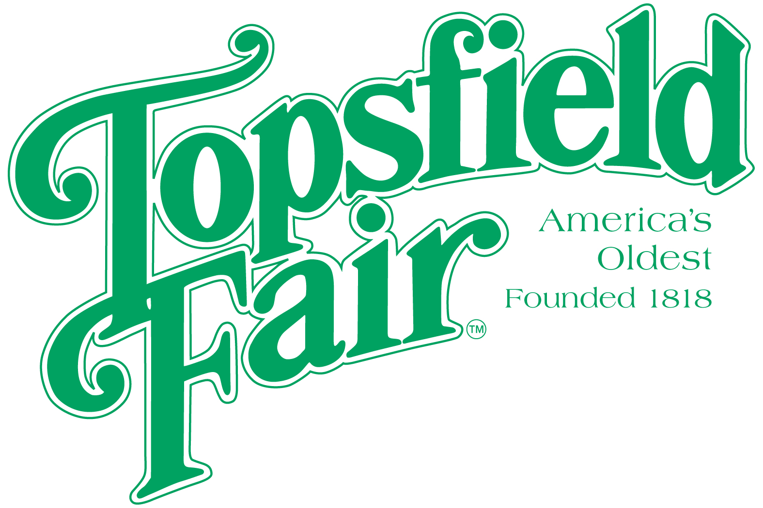
NEWS
RELEASE

Media Contact: David Thomson

Thomson Communications 978-808-7700

ENTER YOUR CHILD IN THE TOPSFIELD FAIR
JUNIOR KING AND QUEEN PAGEANT

Entry Deadline October 3rd

TOPSFIELD, Mass. (September 26, 2025) – Every year the Topsfield Fair hosts a pageant for children between the ages of 5 – 8 years old to become the Junior King or Junior Queen and serve as a representative of the Fair at local parades and other events throughout the year. This year’s pageant will be held at 1:00 p.m. on Saturday, October 4th on the Trianon Stage.

All contestants are asked to be dressed in casual attire. Each child will be interviewed on stage and be judged according to general appearance, conduct, and personality.

To enter your child, download an application found on the ‘Junior King & Queen Pageant’ page on the Exhibitor’s Handbook section of the fair’s website at https://www.topsfieldfair.org/about/exhibitor-handbook.

Ticket prices for the 2025 Topsfield Fair are $20.00 each every day. Discount admission tickets are available at www.topsfieldfair.org through October 2, 2025. General Admission discount tickets can be purchased for only $15.00 plus a $3.00 convenience fee, which are good any day during the Fair’s 11-day run. A three-day pass, good any three days, is available for $42.00 plus a $3.00 convenience fee. Children under eight are free with an adult admission ticket. Discounted food vouchers and ride tickets are also available when purchased in advance at www.topsfieldfair.org.
###

