NEWS
RELEASE
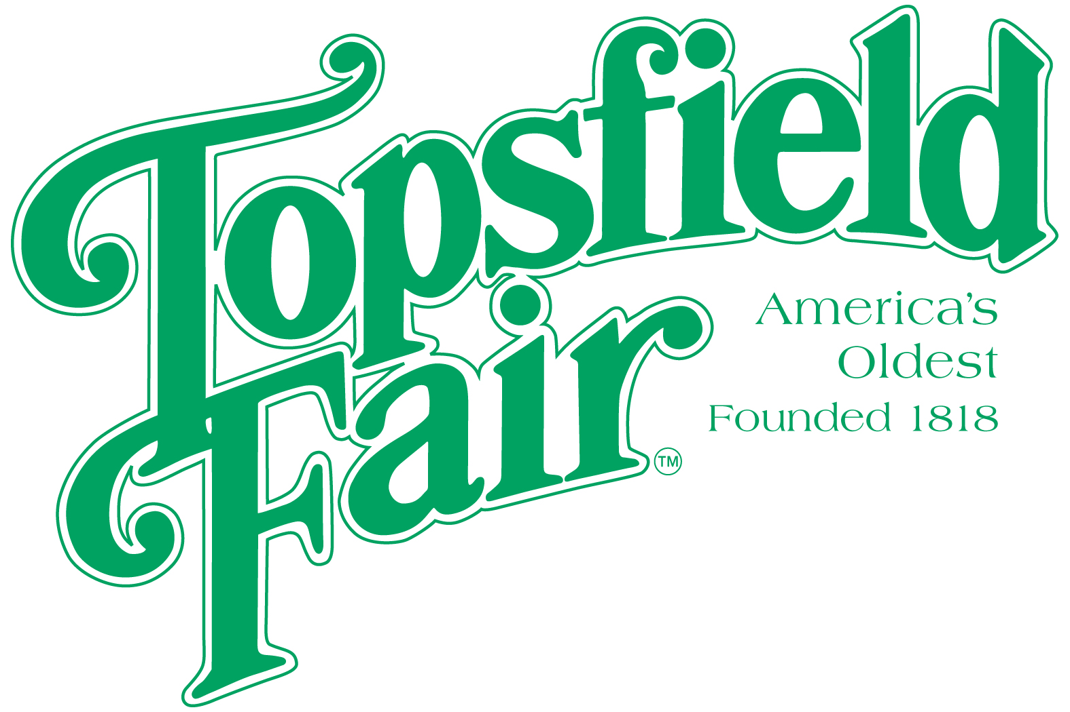

Media Contact: David Thomson

Thomson Communications
978-808-7700

THE TOPSFIELD FAIR TO HOST
7TH ANNUAL HOT DOG EATING CONTEST

Will Last Year’s Record of Nine Quarter Pound Hotdogs in Seven Minutes Be Broken?

TOPSFIELD, Mass. (August 21, 2025) – The Topsfield Fair, running October 3-13, 2025, announces the return of its Hot Dog Eating Contest, sponsored by the B'nai B'rith booth and the Topsfield Fair.

The 7th annual Topsfield Fair Hot Dog Eating Contest will be held on Saturday, October 4, 2025, at 3:00 p.m. on the Trianon Stage.
Contestants, who must be over 16 years of age to participate, will have 7 minutes to consume as many ¼-pound Hebrew National Hot Dogs (including buns) as they can. These jumbo-sized hot dogs are twice the size of standard dogs. The first 12 people to register beginning at 2:30pm on the day of the contest at the Trianon Stage will participate. Each competitor must complete an entry form and a waiver form prior to the deadline for entry. Contestants can also pre-register online at https://tinyurl.com/TFHotDog2025. There is no cost to participate.

“Each contestant will begin with six hot dogs with buns,” said Marc Freedman, who runs the B'nai B'rith booth and oversees the contest. “More hot dogs will be brought to a contestant during the consumption of their last hot dog. Each contestant will also begin the contest with two bottles of water to drink while consuming the hot dogs. Additional water is provided as needed.”

The winner will receive $207 in honor of the 207th Topsfield Fair from the B'nai B'rith booth.

Ticket prices for the 2025 Topsfield Fair are $20.00 each every day. Discount admission tickets are available at www.topsfieldfair.org through October 2, 2025. General Admission discount tickets can be purchased for only $15.00 plus a $3.00 convenience fee, which are good any day during the Fair’s 11-day run. A three-day pass, good any three days, is available for $42.00 plus a $3.00 convenience fee. Children under eight are free with an adult admission ticket. Discounted food vouchers and ride tickets are also available when purchased in advance at www.topsfieldfair.org.
###

