NEWS
RELEASE
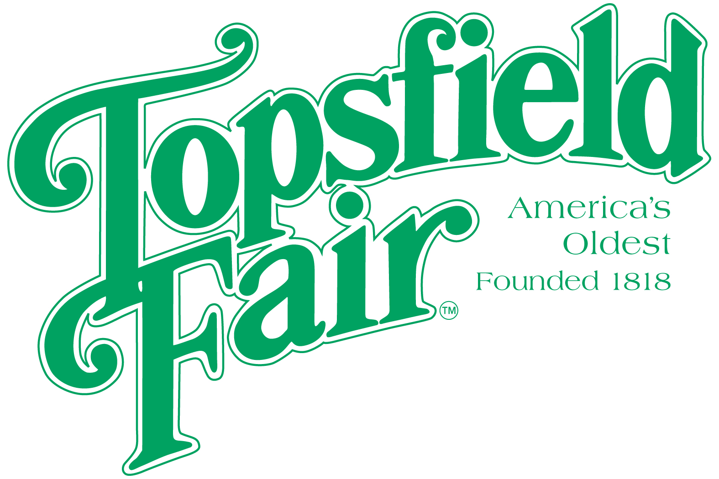

Media Contact: David Thomson

Thomson Communications
978-808-7700

FRANKIE AVALON RETURNS TO THE TOPSFIELD FAIR

TOPSFIELD, Mass. (August 16, 2025) – The 207th Topsfield Fair, running October 3-13, 2025, is pleased to announce that entertainment legend, Frankie Avalon, returns by popular demand to perform on Friday, October 10, 2025.

Frankie Avalon’s years as a “Teenage Idol” evolved into becoming one of the busiest performers in the county. Avalon has a long string of gold record million-seller singles and albums, including: “Venus,” “Just Ask Your Heart,” “Beauty School Dropout,” “Bobby Socks to Stockings,” and “A Boy Without a Girl.”
Frankie Avalon in concert begins at 7:00 p.m. on the Grandstand stage and is free with paid fair admission. “It’s been four years since Frankie Avalon performed at the Fair and I’ve heard from many people asking me to have him back ever since,” said James O’Brien, General Manager, Topsfield Fair.

Ticket prices for the 2025 Topsfield Fair are $20.00 each every day. Discount admission tickets are available at www.topsfieldfair.org through October 2, 2025. General Admission discount tickets can be purchased for only $15.00 plus a $3.00 convenience fee, which are good any day during the Fair’s 11-day run. A three-day pass, good any three days, is available for $42.00 plus a $3.00 convenience fee. Children under eight are free with an adult admission ticket. Discounted food vouchers and ride tickets are also available when purchased in advance at www.topsfieldfair.org.
###

