NEWS
RELEASE
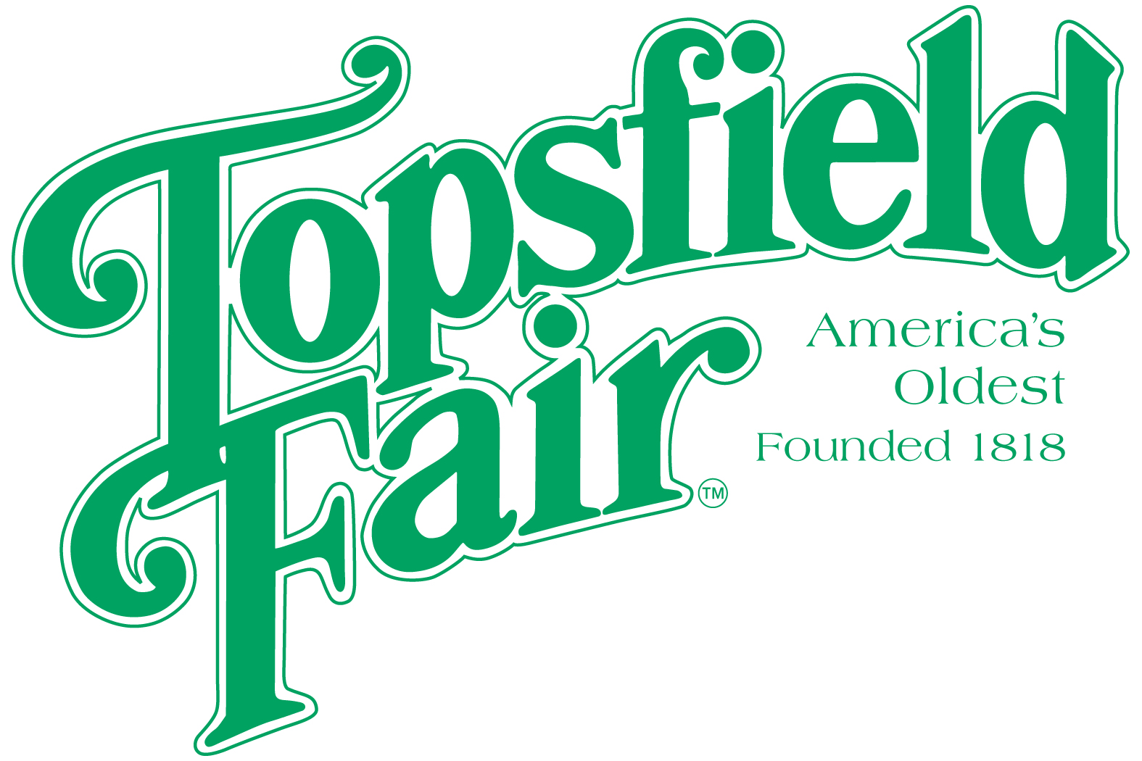

Media Contact: David Thomson

Thomson Communications
978-808-7700

HUNDREDS OF CONTESTS TO ENTER AT THE 2025 TOPSFIELD FAIR

Entry Dates Vary By Category

TOPSFIELD, Mass. (August 14, 2025) – The 207th Topsfield Fair, running October 3-13, 2025, offers hundreds of contests for both amateur and professional entrants. Some of the contests include prize money while others are just for bragging rights. Contestants can upload their entries online. Contests include:
- Beekeeping – Honey Products, Beeswax Products, Arts & Crafts, Cooking with Honey & Spirits, etc. Entry Deadlines vary based on category.
- Canning – Jam, Jelly, Pickles, Preserves, Relish, etc. Entry Deadline: 9/2. Entries accepted on 9/6 from 10:00 a.m.-2:00 p.m.
- Crafts - Ceramic, Crocheting, Doll, Jewelry, Knitting, Needlework, Models, Quilting, Rug, Sewing, Smocking, Spinning, Weaving, Woodworking, etc. Entry Deadline: 9/1. Entries accepted 9/13 & 9/14 from Noon – 4:00 p.m.
- Farm Photography - Theme: Agriculture in Massachusetts. Entry Form and photos must be at the Fair office by 8/29.
- Fine Art (Amateur & Professional) – Painting, Graphics, Photography, etc. Entry Deadline: 9/1. Entries accepted 9/6 & 9/7 from Noon – 4:00 p.m.
- Flowers – Bonsai, Dahlias & Zinnias, Roses, Sunflowers, Hanging Basket, Holiday Decoration, House Plants, Terrariums, etc. Entry Deadline: 9/29. Entries accepted 10/2 from 10:00 a.m. – 6:00 p.m.
- Foods – Topsfield Fair Fall Harvest Baked Sweet Treat Contest, King Arthur Baking Company Contest (Theme: Frosted Cupcake), Topsfield Fair Apple Pie Contest, Parent & Child Cookie Celebration Contest (Theme: Decorated Sugar Cookies). Entry deadlines vary.
- Fruit – Apples, Berries, Crabapples, Grapes, Peaches, Pears, Plums, Quinces. Entry Forms Due and Entries accepted on 10/2 from 7:00 p.m.-9:00 p.m.
- Giant Pumpkins – Over $15,000 in prize money up for grabs. Entry Deadline: 9/19. Weigh-off to be held on 10/3.
- Junior Fruit, Vegetable & Decorative – Enter your decorated pumpkin, gourds and more! Entry Deadline: 9/19.
- Open & Youth Poultry –Standard Poultry, Eggs, Bantams, Cock Crowing, Hen Flying, Turkeys, Pigeons, Non-Standard Barnyard Rooster, Poster. Entry Deadline: 9/26. Entries accepted 10/3 from 11:00 a.m. – 8:00 p.m. *There will be no waterfowl entries this year.
- Vegetables – Beans, Beets, Carrots, Cucumbers, Lettuce, Onions, Potatoes, Peppers, Squash, Tomatoes, and many more categories. Entry Deadline: 9/26. Entry Entries accepted on 10/2 from 5:00pm-9:00p.m.
Additional categories include Cattle, Christmas Trees, Draft Horse Show, Grange, Horse & Oxen Pulling, Rabbit & Cavy, Sheep, Sheep Dog Trial, Stock Farm Tractor Pulling, Winemaking, 4-H Club, and many others. Entry deadlines vary.

There are also two pageants held annually at the Topsfield Fair

      - Junior King & Queen - For children ages 5–8, who will be judged on general appearance, conduct and personality. Each child will be interviewed on stage. All contestants will be asked to be dressed in casual attire. Entry Deadline:10/3. Pageant to be held on 10/4 at 1:00pm.

      - Mrs. Essex County – Contestants must be married, at least 18 years old, currently living in Essex County with their spouse. Each contestant will submit a prepared food item. A preliminary interview will be conducted, and selected participants will appear in the pageant in elegant cocktail wear and will be judged on general appearance, personality, poise, and food score. Entry Deadline: 10/9. Pageant to be held on 10/12 at 1:00pm.

Entry forms are available at www.topsfieldfair.org. Information on each contest can be found in the “Exhibitor’s Handbook” under the “About” section on the home page of the website. Contact information for the person responsible for each contest is included with the contest form for each department. Requirements and entry deadlines vary for each contest. Please see the Topsfield Fair website for more information.

###

